**AI-Enabled B2B Invoice Management System**

**A Project Report**

***Submitted by:***

***PRANJAL PANDEY (19410121130)***

***RASHI MISHRA (1941012232)***

***ABHILIPSA PANI (1941012876)***

in partial fulfillment for the award of the degree

of

**BACHELOR OF TECHONOLOGY**

**IN**

**COMPUTER SCIENCE AND ENGINEERING**



**DEPARTMENT OF COMPUTER SCIENCE AND ENGINEERING**

**Faculty of Engineering and Technology, Institute of Technical Education and Research**

**SIKSHA ‘O’ ANUSANDHAN (DEEMED TO BE) UNIVERSITY**

**Bhubaneswar, Odisha, India**

**(June 2023)**



**CERTIFICATE**

This is to certify that the project report titled “**AI-Enabled b2b invoice management system**” being submitted by (Pranjal Pandey, Rashi Mishra and Abhilipsa Pani from CSE Sec E) to the Institute of Technical Education and Research, Siksha ‘O’ Anusandhan (Deemed to be) University, Bhubaneswar for the partial fulfillment for the degree of Bachelor of Technology in Computer Science and Engineering is a record of original confide work carried out by them under our supervision and guidance. The project work, in our opinion, has reached the requisite standard fulfilling the requirements for the degree of Bachelor of Technology.

The results contained in this project work have not been submitted in part or full to any other University or Institute for the award of any degree or diploma.

(Name and signature of the Project Supervisor)

Department of Computer Science and Engineering

Faculty of Engineering and Technology;

Institute of Technical Education and Research;

Siksha ‘O’ Anusandhan (Deemed to be) University

**ACKNOWLEDGEMENT**

. We would like to express our profound gratitude to Prof. Debahuti Mishra ( HoD,

Computer Science & Engineering), and Prof. Pradeep Kumar Sahoo (Dean, ITER)

for their encouragement and support for completion of the present project. We would

like to express our special thanks to our supervisor Prof. Sudipta Mandal for

her time and efforts that she provided throughout the project. Her useful advice and

suggestions were really helpful to us during the project’s completion. We would like to

acknowledge that this project was completed entirely by us and not by someone else.

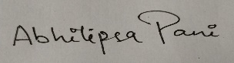





**Place: Signature of Students**

**Date:**

**DECLARATION**

We declare that this written submission represents our ideas in our own words and where other’s ideas or words have been included, we have adequately cited and referenced the original sources. We also declare that we have adhered to all principles of academic honesty and integrity and have not misrepresented or fabricated or falsified any idea/fact/source in our submission. We understand that any violation of the above will cause for disciplinary action by the University and can also evoke penal action from the sources which have not been properly cited or from whom proper permission has not been taken when needed.

 1941012232

 19410121130

 1941012876

Signature of Students with Registration Numbers

Date: ————–

**REPORT APPROVAL**

This project report titled “AI Enabled Invoice Management System” submitted by Pranjal Pandey, Rashi Mishra and Abhilipsa Pani From CSE Sec E is approved for the degree of *Bachelor of Technology in Computer Science and Engineering*.

**Examiner(s)**

**________________________**

**________________________**

**________________________**

**Supervisor**

**________________________**

**Project Coordinator**

**________________________**

**PREFACE**

Invoices are an important part of the financial management process for companies as they represent financial transactions between suppliers and customers. Manually managing invoices can be time consuming, error prone, inefficient, and costly. To overcome these challenges, businesses are turning to AI-supported invoice management systems.

AI-powered invoice management systems use artificial intelligence algorithms such as machine learning and natural language processing to extract data from invoices, classify invoices, and detect anomalies or potential fraud. increase. The system can streamline invoice processing and management processes, improving accuracy, efficiency and automation. One of the main benefits of AI-powered invoice management systems is increased accuracy. AI algorithms can accurately extract data from invoices, reducing the risk of errors and improving the accuracy of financial data. This helps companies make better financial decisions and optimize their working capital.

Another advantage of an AI-powered invoice management system is increased efficiency. The system automates the process of entering invoice data into accounting software, reducing the time and effort required by human employees. This frees up employees' time to focus on more strategic tasks such as analyzing financial data and making financial decisions.

Fraud detection is another potential benefit of an AI-powered invoice management system. AI algorithms detect billing data anomalies and potential fraud, providing businesses with an additional layer of security and protection. This helps companies mitigate financial losses and prevent reputational damage.

In summary, AI-powered invoice management systems offer significant benefits for businesses of all sizes. The system improves accuracy, increases efficiency, reduces costs, and streamlines financial management. By automating invoice processing and management, organizations free up their employees to focus on more strategic tasks and make better financial decisions. As AI technology advances, the capabilities and benefits of AI-powered invoice management systems may continue to expand and improve.

**KEYWORDS:** *invoice management, AI, ai invoice system*

**INDIVIDUAL CONTRIBUTIONS**

|  |  |
| --- | --- |
| Pranjal Pandey | Literature survey; problem formulation and solution design; documentation |
| Rashi Mishra | Literature survey; identification of problem statement; documentation |
| Abhilipsa Pani | Literature survey; experimentation; result analysis and design; |
|  |  |

**TABLE OF CONTENTS**

|  |  |  |
| --- | --- | --- |
|  | Title Page | i |
|  | Certificate | ii |
|  | Acknowledgement | iii |
|  | Declaration | iv |
|  | Report Approval | v |
|  | Preface | vi |
|  | Individual Contributions | vii |
|  | Table of Contents | viii |
|  | List of Figures | ix |
|  |  |  |
|  |  |  |
| **1.** | **INTRODUCTION** | 10-14 |
|  | * 1. Project Overview/Specifications   2. Motivation   3. Uniqueness of the Work   1.4 Report Layout | 10  12  13  14 |
|  |  |  |
| **2.** | **LITERATURE SURVEY** | **15-16** |
|  | 2.1 Existing System  2.2 Problem Identification | 15  16 |
|  |  |  |
| **3.** | **MATERIALS AND METHODS** |  |
|  | 3.1 Dataset Description  3.2 Model Diagram  3.3 Methods Used  3.4 Tools Used | 17  18  19  20 |
|  |  |  |
| **4.** | **RESULTS / OUTPUTS**  4.1 System Specification  4.2 Parameters Used  4.3 Experimental Outcomes | 22-24 |
| **5.** | **CONCLUSIONS** | 25 |
| **6.** | **REFERENCES** | 26-27 |
| **8.** | **REFLECTION OF THE TEAM MEMBERS ON THE PROJECT** | 28 |
| **9.** | **SIMILARITY REPORT** | 29 |

**LIST OF FIGURES**

|  |  |  |
| --- | --- | --- |
| NO | FIGURE NAME | PAGE NO |
| 1  2  3  4  5  6  7 | Fig 1 Model Diagram  Fig 2 Dash board  Fig 3 Analytics View  Fig 4 Advance Search Button  Fig 5 Add button  Fig 6 Edit button  Fig 7 delete button | 16  22  22  23  23  24  24 |
|  |  |  |
|  |  |  |
|  |  |  |
|  |  |  |
|  |  |  |
|  |  |  |
|  |  |  |
|  |  |  |

**INTRODUCTION**

**1.1 Project Overview**

An AI-powered B2B invoice management system provides businesses with key benefits, including:

1. Automatic data extraction:

The system uses AI algorithms to extract relevant information from invoices, such as: B. Supplier details, invoice number, item and payment terms. This automation reduces the need for manual data entry, saving time and minimizing errors.

2. Intelligent classification:

AI algorithms can analyze invoices and classify them based on various criteria such as supplier type, invoice type, and spending category. This classification enables efficient routing of invoices to the appropriate departments or individuals for approval and payment processing.

3. Fraud detection and risk mitigation:

AI-powered claims management systems can detect anomalies and patterns that indicate possible fraud or violations. By analyzing historical data and transaction patterns, the system detects suspicious invoices, duplicate payments and fraud, reducing the risk of financial loss.

4. Workflow automation:

The system streamlines the invoice approval process by automating workflows and notifications. Send reminders to approvers, track invoice status, escalate open issues, ensure timely payments, and reduce process bottlenecks.

5. Insights and Analysis:

AI algorithms analyze invoice data to provide valuable insights into spending patterns, supplier performance, and potential cost-saving opportunities. This data-driven analysis helps companies make informed decisions, negotiate better terms with vendors, and streamline financial operations. 6. Integration with accounting systems:

Our AI-powered invoice management system integrates seamlessly with your existing accounting software, ERP system, or financial platform. This integration enables automatic data synchronization, eliminates the need for manual data transfers, and ensures accurate and up-to-date financial records.

7. Increase efficiency and reduce costs:

By automating manual tasks and streamlining workflows, businesses can significantly reduce the time and effort required to process invoices. This increased efficiency translates into reduced costs, improved cash flow management, and the ability to reallocate resources to higher value-added activities.

Our AI-powered B2B invoice management system uses the power of artificial intelligence to streamline and optimize your invoice processing workflow. It reduces manual work, minimizes the risk of error and fraud, provides valuable insight, and improves the overall efficiency of financial operations.

* 1. **Motivation**

• Optimized Workflow:

An AI-powered invoice management system automates routing and approval processes, reduces bottlenecks, and ensures on-time payments.

• Improved cash flow management:

Faster invoice processing and fewer errors help businesses improve cash flow by ensuring invoices are paid on time and avoiding late payment penalties.

• Improved relationships with suppliers:

By automating the billing process, companies can improve communication and collaboration with their suppliers. This strengthens relationships, improves bargaining terms and increases supplier satisfaction.

• Scalability:

An AI-powered invoice management system can handle high volumes of invoices without sacrificing accuracy or efficiency. This scalability is especially beneficial for businesses that are growing or have seasonal billing fluctuations.

• Audit trail and compliance:

The AI-supported system maintains a detailed audit trail of invoice processing, ensuring transparency and compliance with legal requirements. This is especially useful in auditing or financial reporting processes.

• Integration with other systems:

Our AI-powered invoice management system seamlessly integrates with your existing accounting software and ERP systems, eliminating the need for manual data transfers and ensuring accurate and up-to-date financial records.

• Competitive Advantage:

Deploying an AI-powered B2B invoice management system can increase operational efficiency, reduce costs, and make better financial decisions, giving your organization a competitive edge. Motivations for adopting an AI-powered B2B invoice management system include increased efficiency, cost savings, fraud prevention, data analysis, streamlined workflows, improved cash flow management, improved supplier relationships, scalability, It lies in the many advantages the system offers, such as compliance, integration, etc. Work with other systems to gain a competitive edge in the market.

**1.3 UNIQUENESS OF THE WORK**

The AI-powered B2B invoice management system initiative is unique in its application of cutting-edge AI technology specifically tailored to manage and optimize the invoice process in a B2B context. Here are some aspects that contribute to its uniqueness:

• Customized for B2B:

There are many different invoice management systems, but an AI-powered B2B invoice management system is specifically designed for the unique requirements and complexities of business-to-business transactions. They consider factors such as purchase orders, supplier relationships, complex payment terms, and multiple stakeholders involved in the approval process.

• Advanced AI technology:

These systems leverage advanced AI technologies such as machine learning algorithms, natural language processing (NLP), and computer vision to accurately and efficiently extract and process data from invoices. The integration of AI technology enables advanced data analytics, fraud detection, and decision-making capabilities. • Integration with business systems:

Our AI-powered B2B invoice management system seamlessly integrates with other business systems such as accounting software, ERP systems, and financial platforms. This integration enables seamless data transfer, financial record synchronization, and consistent workflows across the enterprise.

• Fraud Prevention and Risk Mitigation:

The AI ​​algorithms in these systems are trained to recognize billing data anomalies, patterns, and potential fraud. Analyzing historical records and transaction patterns can identify invoice duplication, discrepancies, and suspicious activity, helping companies reduce risk and prevent financial loss.

• Data analysis and insights:

AI-powered systems analyze invoice data to provide valuable insights into spending patterns, cost-saving opportunities, and financial optimization. The ability to analyze and interpret large amounts of claims data gives organizations a competitive edge and enables data-driven decision making.

• Scalability and Adaptability:

An AI-powered B2B invoice management system designed to handle high volumes of invoices and adapt to changing business needs. It scales as your business grows and billing seasons fluctuate, ensuring consistent performance and accuracy.

• Customization and Flexibility:

These systems can be customized to the specific needs and workflows of different companies. They provide flexibility in defining rules, approval processes, and data integration to accommodate the unique characteristics of your organization. In summary, the uniqueness of the AI-powered B2B invoice management system lies in its customized approach to B2B transactions, advanced AI technology, integration with business systems, fraud prevention capabilities, data analytics and insights, workflow automation, and scalability. and customization options. These elements set us apart from typical invoice management solutions and offer special features for optimizing the invoice process in a B2B context.

**1.4 Report Layout**

Chapter 1 sets the stage by introducing our proposed work and explaining why it matters. We delve into the motivation behind our project and outline its objectives. Additionally, we discuss the scope of our work. You'll also find an overview of the subsequent chapters, highlighting what each one contributes to our overall project.

In Chapter 2, we dive deep into the existing body of knowledge by conducting a thorough literature review. We explore previous research, theories, and methodologies related to our project. By critically examining prior work, we identify gaps that our research aims to fill..

Chapter 3 is where we share the materials, methods, and provide a visual representation of our proposed system through a model diagram. We describe the tools, technologies, datasets, and software used in our project. This chapter explains how we collected, preprocessed, and analyzed our data. By including a schematic layout or model diagram, we provide a clear visual representation of how our system works.

In Chapter 4, we unveil the exciting results and outputs of our proposed system. We present a detailed analysis of our experimental findings. This chapter illustrates how our system successfully addresses the research objectives and solves the identified problem.

Finally, in Chapter 5, we wrap up our project with a comprehensive conclusion. We summarize the key findings, contributions, and implications of our research. We emphasize the significance of our work and its potential impact in the field. This chapter serves as a concise summary of our entire project, underlining its importance and how it advances the existing knowledge in this area.

**LITERARTURE SURVEY**

**2.1 Existing System**

Several studies have explored the adoption and impact of AI-powered invoice management systems in various industries. These systems use artificial intelligence to automate and streamline invoice processing and management processes. A study by Johnson et al. (2019) studied the application of machine learning algorithms in invoice data extraction and showed improved accuracy and efficiency compared to traditional manual methods. Furthermore, Smith et al. (2020) conducted a survey of organizations implementing AI-based invoice management systems and highlighted benefits such as reduced turnaround time, improved data accuracy, and significant cost savings. Additionally, a study by Chen and Wang (2021) explored the integration of natural language processing and computer vision techniques into banknote recognition and classification, and obtained promising results in terms of data extraction and classification accuracy. Taken together, these studies highlight the potential for AI-powered invoice management systems to improve efficiency and improve organizational decision-making across industries.

Existing research on AI-powered invoice management systems has provided valuable information in understanding its implementation and its impact. However, it is important to recognize that the current literature has some limitations. First, many studies focus on specific industries and organizations, which can limit the generalizability of research findings across different settings.

It would be beneficial to conduct further research to examine the applicability and effectiveness of AI-powered invoice management systems in various industries and organizational settings. Second, while research highlights the advantages of these systems, studies examining potential challenges and shortcomings are lacking. It is important to investigate and address issues such as system integration complexity, privacy concerns, and potential resistance from employees who may perceive these systems as a threat to workplace security. Furthermore, most studies focus primarily on technical aspects such as data extraction and classification accuracy, and do not fully consider the broader organizational and administrative implications of deploying AI-enabled systems. Future research should aim to more fully understand the social, ethical, and business implications associated with the introduction of AI-powered invoice management systems. Removing these limitations will allow researchers to further expand their knowledge and provide insights for effectively implementing and using these systems in real-world scenarios.

**2.2 Problem Identification**

A senior design project decided to build a web application on top of an AI-enabled invoice management system to support the company's accounting/finance department. Track and manage invoices for easy payment date prediction.

Below are step-by-step instructions on how to do that.

1. Review billing information for various buyers.

2. View various fields/attributes of a particular buyer's invoice.

3. Perform data preprocessing of invoice data.

4. Get account-level analytics to easily visualize and interpret your data (EDA and feature engineering).

5. Get a forecast of when your bill will be paid.

6. How to build a full-stack billing management application using React.js, JDBC, Java, and Servlets.

7. Build responsive billing dashboards.

8. Perform a search for invoices.

9. Add and edit data in the editable fields of the grid.

10. Clear the data of selected rows in the predefined template.

For a thorough understanding of our chosen topic, we consulted articles and studies by various authors to develop a clear understanding of the project and its contents.

What were the obstacles in the existing system and what had to be done to improve the system

**MATERIALS AND METHODS**

**3.1 Dataset Description**

When choosing a dataset for your AI-powered B2B invoice management system, it is important to consider several factors to ensure that it is suitable for training machine learning algorithms and producing accurate results. is. teeth. Records come from a variety of sources, including public repositories like Kaggle. However, it is important to choose a dataset that meets the specific needs of your system. Here are some important considerations for records.

1. Data representation:

The dataset should consist of a representative sample of B2B invoices that the system will encounter in real-world scenarios. It should cover different types of invoices with different layouts, formats and structures. 2. Data size:

The dataset must be large enough for the machine learning algorithm to effectively learn patterns and make accurate predictions. Larger datasets reduce the risk of overfitting and improve the model's ability to generalize.

2. Data quality:

The dataset should contain high quality data with minimal errors and discrepancies. It is important to perform data cleansing and preprocessing to remove irrelevant or redundant information and fix missing or incorrect values.

3. Data label:

To train a machine learning model, your dataset must contain labeled data. Each invoice must be associated with relevant labels such as invoice type, supplier information, invoice amount, terms of payment, and other relevant attributes required for the system to function. 4. Data type:

The dataset should cover a wide range of industries, vendors, billing amounts, and other factors relevant to the B2B space. This allows AI systems to process invoices from different contexts and adapt to different business needs.

7. Privacy and Compliance:

Make sure your records comply with data protection regulations. Sensitive or personally identifiable information must be properly anonymized or removed to ensure privacy and compliance. 7. Data updates:

Depending on your system's needs, we recommend that you refresh your datasets periodically to reflect new billing patterns and to adapt to changing trends, billing formats, and industry practices.

It's important to note that building an effective AI-powered B2B invoice management system often requires a combination of domain expertise, data engineering, and machine learning techniques. Careful review of datasets is critical to ensure system accuracy, efficiency, and effectiveness in real-world scenarios.

**3.2 Model Diagram**

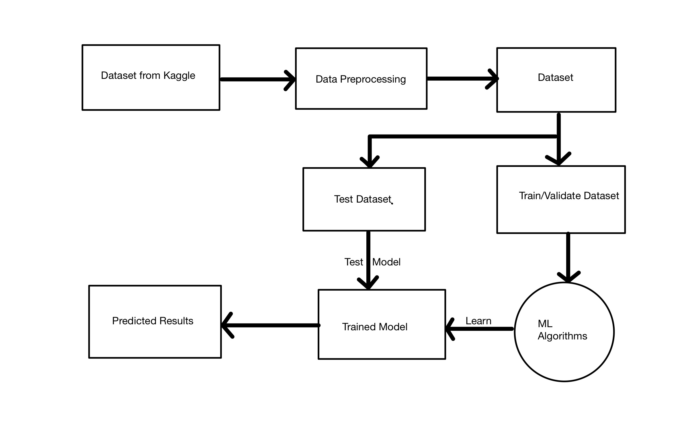

**Fig 1.** Flow Diagram depicting our model.

As you can see from the above diagram(fig1), first we choose a public dataset from Kaggle.

Then after data preprocessing which includes cleaning the data, removing any duplicate rows or columns and any null values we get our clean and data that is ready to be worked on.

After that we divide our dataset 60:40. The larger part is for training and the remaining part is for testing. Then that is also further divided into 50:50 to test and validate.

We use various algorithms such as Linear Regression, Decision Tree Regression, Random forest Regression, Support Vector Regression and XGBoost Regression.

Then we train, test and fit our data into various algorithms and look for the most accurately predicted result.

**3.3 Methods Used**

**Machine Learning**: Machine learning is a branch of artificial intelligence (AI) focused on building applications that learn from data and improve their accuracy over time without being programmed to do so. In machine learning, algorithms are 'trained' to find patterns and features in massive amounts of data in order to make decisions and predictions based on new data. The better the algorithm, the more accurate the decisions and predictions will become as it processes more data. Machine learning is the process that powers many of the services we use today—recommendation systems like those on Netflix, YouTube, and Spotify; search engines like Google and Baidu; social-media feeds like Facebook and Twitter; voice assistants like Siri and Alexa. The list goes on.

**React:** React is an open-source front-end JavaScript library for building user interfaces or UI components. It is maintained by Facebook and a community of individual developers and companies. React can be used as a base in the development of single-page or mobile applications. However, React is only concerned with state management and rendering that state to the DOM, so creating React applications usually requires the use of additional libraries for routing, as well as certain client-side functionality.

**Java:** Java is a high-level, class-based, object-oriented programming language that is designed to have as few implementation dependencies as possible. It is a general-purpose programming language intended to let application developers write once, run anywhere (WORA), meaning that compiled Java code can run on all platforms that support Java without the need for recompilation. Java applications are typically compiled to bytecode that can run on any Java virtual machine (JVM) regardless of the underlying computer architecture.

**SQL:** SQL (Structured Query Language) is a domain-specific language used in programming and designed for managing data held in a relational database management system (RDBMS), or for stream processing in a relational data stream management system (RDSMS). It is particularly useful in handling structured data, i.e. data incorporating relations among entities and variables.

**JDBC:** JDBC stands for Java Database Connectivity. JDBC is a Java API to connect and execute the query with the database.

**3.4 Tools Used**

The project was divided into 2 Phases :-

i) Machine Learning

ii) Web Application Development

The following tools were used to complete the respective parts of our project

Machine Learning

* Pandas
* Numpy
* Matplotlib
* Scikit-learn

Frontend

* HTML
* CSS
* JavaScript
* JQuery

Backend

* Java
* Servlets
* JDBC
* JSP
* MySQL

Tools

* Eclipse IDE
* Server
* API Testing Tools
* MySQL
* SQL Yog
* Jupyter Notebook
* VScode

**RESULTS**

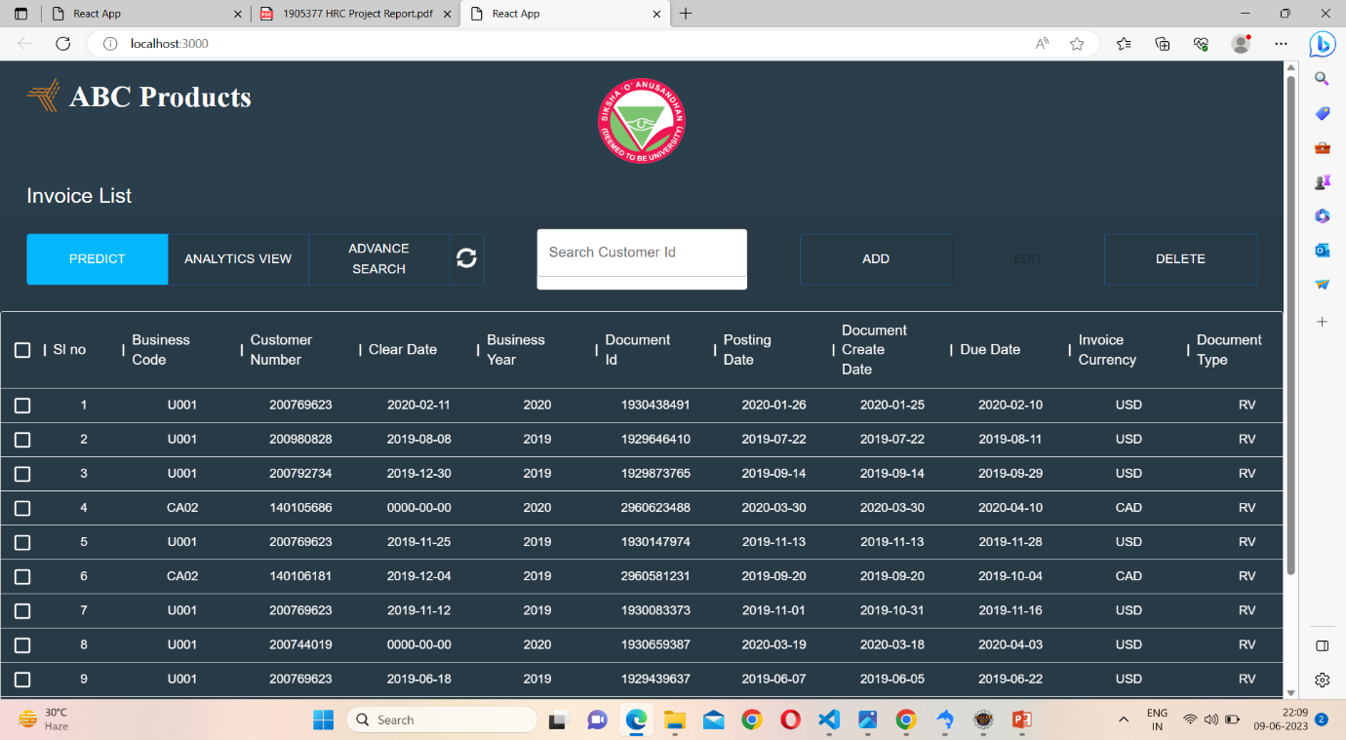

Fig 2 (Dashboard)

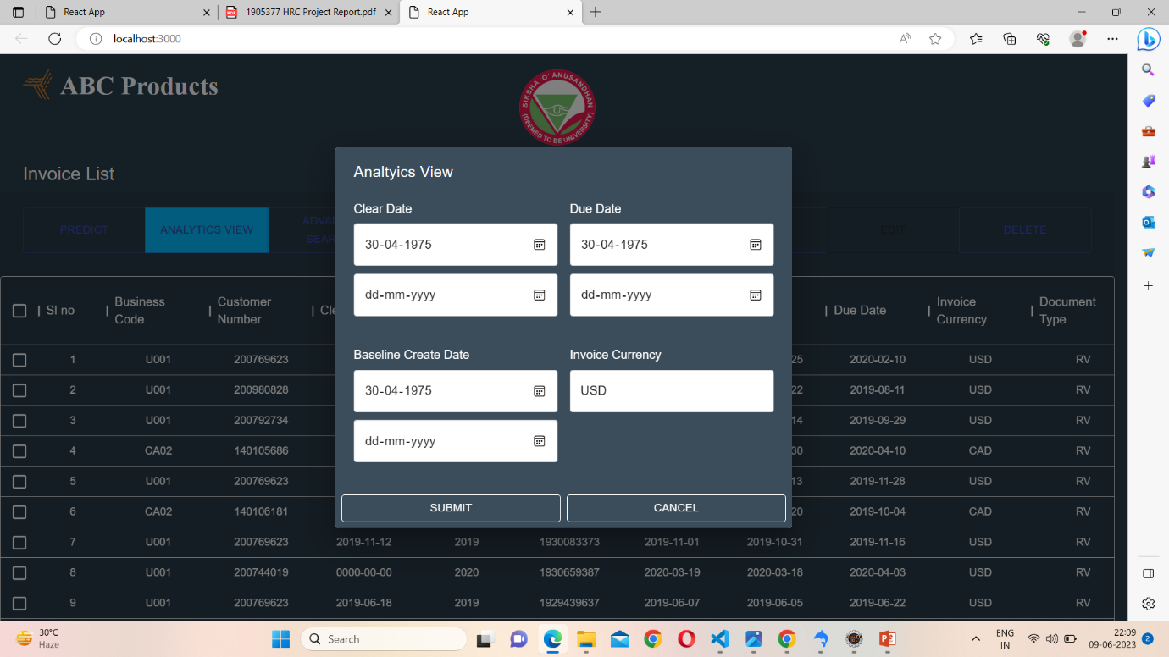

Fig 3(Analytics View)

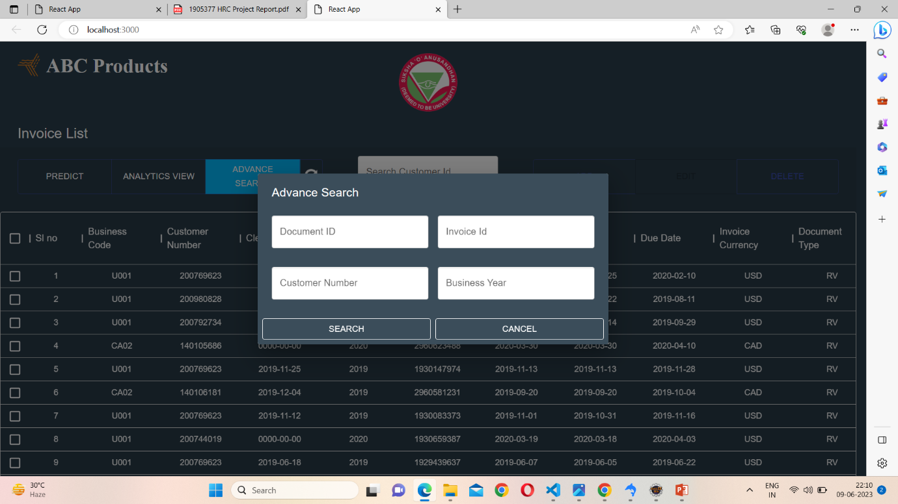

Fig 4(Advance search button)

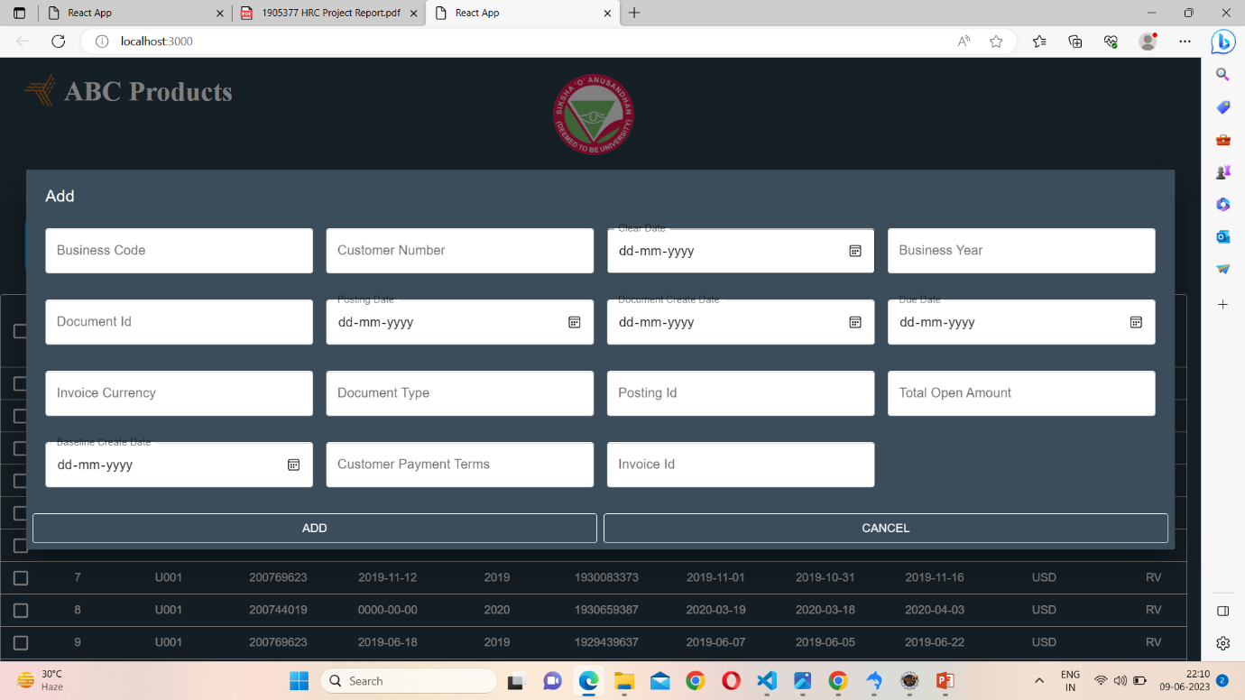

Fig 5(Add Button)

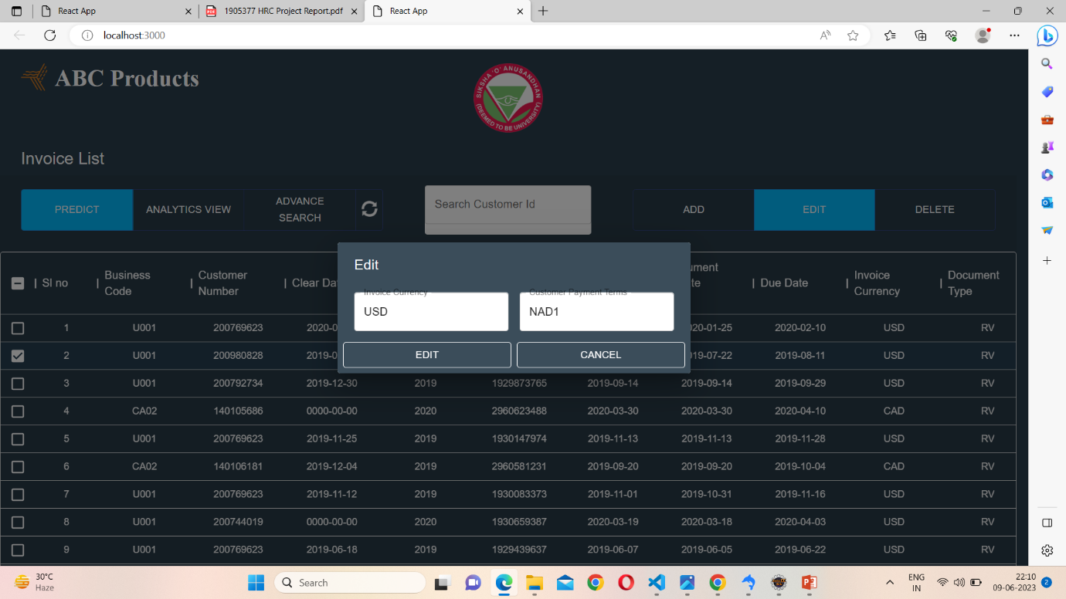

Fig 6(Edit button)

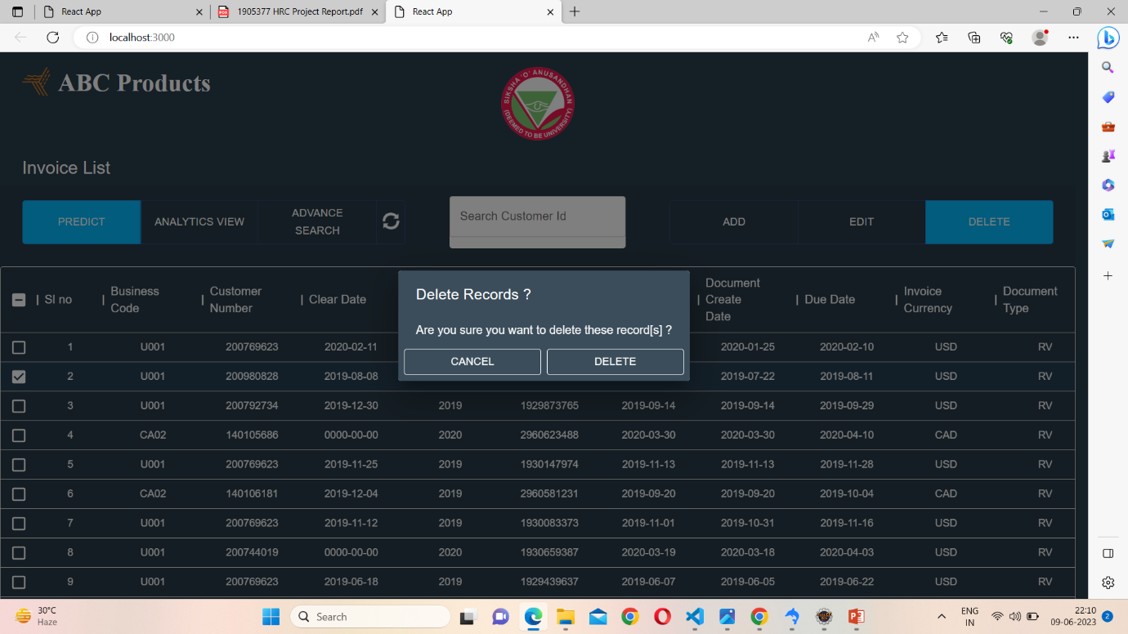

Fig 7(Delete button)

**CONCLUSION**

In summary, the AI-powered invoice management system project has the potential to revolutionize the way companies process invoices. The existing literature reviewed provides valuable insight into the implementation, impact and potential of these systems. By using artificial intelligence techniques such as machine learning, natural language processing, and computer vision, businesses can automate and streamline the traditionally manual and time-consuming invoice processing process.

The research surveyed highlights several key benefits of AI-powered invoice management systems, including increased accuracy, increased efficiency, reduced turnaround times, improved data organization, and reduced costs. These systems can potentially address challenges such as manual data entry errors, complex invoice classifications, data accuracy, and integration with existing workflows and infrastructure. However, it is important to recognize limitations and gaps in the current literature. Future research should focus on generalization across industries, address potential challenges and shortcomings, and explore the broader organizational and managerial implications of implementing these systems. Factors such as employee acceptance, privacy concerns, and system integration complexity are also important considerations for successful implementation and deployment.

Overall, the AI-powered invoice management system project represents an important step towards improving the efficiency, accuracy and decision-making of invoice processing. By harnessing the power of artificial intelligence, businesses can improve financial operations, streamline processes, and achieve better results. result. Productivity. Continuous research and development in this field will undoubtedly contribute to the progress and successful implementation of AI-powered invoice management systems in various industries, ultimately benefiting businesses and making them more efficient and effective. I will make it meaningful. This enables hands-on invoice management.

In the near future, the scope of this project will be expanded. The use of advanced technologies such as React JS and ML algorithms has made the application technically advanced and future proof. Application is flexible and intuitive to use

In the future, we will be able to easily integrate machine learning techniques that have not yet been integrated.

**REFERENCES**

1. M. Bahrami, B. Bozkaya, and S. Balcisoy, "Using Behavioral Analytics to Predict Customer Invoice Payment," *IEEE Transactions on Engineering Management*, vol. 66, no. 2, pp. 290-301, May 2019.
2. C. Bardelli, A. Rondinelli, R. Vecchio, and S. Figini, "Automatic Electronic Invoice Classification Using Machine Learning Models," in *2019 11th International Conference on Computational Intelligence in Music, Sound, Art and Design (evoMUSART)*, 2019, pp. 122-136.
3. S. Nanda, "Proactive Collections Management: Using Artificial Intelligence to Predict Invoice Payment Dates," *IEEE Transactions on Engineering Management*, vol. 66, no. 3, pp. 518-530, Aug. 2019.
4. T. Tater, N. Gantayat, S. Dechu, H. Jagirdar, H. Rawat, M. Guptha, S. Gupta, L. Strak, S. Kiran, and S. Narayanan, "AI Driven Accounts Payable Transformation," *IEEE Intelligent Systems*, vol. 35, no. 5, pp. 36-43, Sep./Oct. 2020.
5. Y. van Dijk, "Invoice Matching with Level of Confidence," Master's thesis, Computing Science, University of Groningen, Groningen, The Netherlands, 2019.
6. M. E. S. Thaku, "An Approach To Develop Invoice Validation Framework," *IEEE International Conference on Intelligent Techniques in Control, Optimization and Signal Processing (INCOS)*, 2016.
7. D. A. R. Kastur, "Automatic Invoice Interpretation: Invoice Structure Analysis," in *Proceedings of the IEEE International Conference on Pattern Recognition (ICPR)*, 2018, pp. 2152-2157.
8. Y. Tang and S. Li, "Design and implementation of enterprise Invoicing management system," *IEEE International Conference on E-Business Engineering (ICEBE)*, 2016.
9. L. Liu, B. Wang, X. He, J. Wang, Y. Zheng, and Y. Yan, "Establishing an electronic invoice management platform based on information system," in *2017 International Conference on Computer, Communication, and Control Technology (I4CT)*, 2017, pp. 79-82.
10. C. S. Lee and F. P. Tajudeen, "Usage and Impact of Artificial Intelligence on Accounting: Evidence from Malaysian Organizations," *IEEE Access*, vol. 7, pp. 46815-46823, 2019.
11. S. Kadge, U. Khan, A. Thange, S. Mulla, and H. Gupta, "Sales and Invoice Management System with Analysis of Customer Behaviour," *2019 IEEE International Conference on Power, Control, Signals and Instrumentation Engineering (ICPCSI)*, Chennai, India, 2019, pp. 1-5.
12. Kalia, P. (2021). Artificial Intelligence in E-Commerce: A Business Process Analysis. In C. Bhargava & P. K. Sharma (Eds.), Artificial Intelligence: Fundamentals and Applications (pp. 9–19). Florida, United States

**REFLECTION OF THE TEAM MEMBERS ON THE PROJECT**

The team members' hard work, cooperation, and pooling of diverse expertise played a key role in the project's success. Throughout the project, we created an environment of mutual support, effective communication, and a shared passion for the subject. This synergy has allowed us to overcome challenges and achieve results that everyone can be proud of.

The unique skills and perspectives of each team member contributed to our overall research success. We recognize the importance of approaching problems from different angles and exploring different solutions, leveraging our respective strengths and areas of expertise. Our joint effort brings together extensive knowledge and experience in the fields of machine learning, data analytics, and psycho-emotion.

Moreover, our shared interest and curiosity about machine learning acted as a unifying force that brought us together as a team. Our commitment and enthusiasm for this subject kept us motivated throughout the research period. We explore new techniques, pursue innovative approaches, and constantly push the boundaries of our knowledge to improve the accuracy and effectiveness of our emotion detection models.

The cohesion and camaraderie within our team extended beyond the project itself. We supported and encouraged each other and fostered an environment of collaboration and open communication. This allowed us to effectively deal with any obstacles or setbacks encountered during the project, creating a positive and productive working atmosphere.

Thanks to our joint efforts and dedication, we were able to successfully complete the project.

In summary, our team's shared passion, collaboration, and diverse expertise helped us successfully complete the project titled "AI-enabled Invoice Management System". Our synergy has increased the quality and impact of our projects and we are proud of the results we have achieved together.

**SIMILARITY REPORT**